|  |  |
| --- | --- |
| **Title:** | **Door Control Module**  **Door Driver Component** |

|  |  |  |  |  |
| --- | --- | --- | --- | --- |
| **History** | | | | |
| **Issue status**  (Index) | **Maturity/Date**  (draft/invalid/valid)  (dd-mmm-yyyy) | **Author**  Department | **Check/Release**  Department | **Description** |
| 1.0 | Draft  30/08/2021 | Marco Mares | Marco Mares | Creation of the document |

Table of Contents

1 Purpose 3

2 Definitions and abbreviations 3

3 Realization constraints and targets 3

4 SW Conceptual design 3

5 SW Component internal breakdown 4

5.1 Functional Decomposition 4

*5.2* Function *<Type> <function name> (type par 1, .., type par n)* 5

*5.3* Function <Type*> <function name> (type par 1, .., type par n)* 5

# Purpose

This document has been created as a demonstration the students to how to create the detailed design from requirements and SW architecture.

# Definitions and abbreviations

**Definitions**

|  |  |
| --- | --- |
| Special Byte | Special byte received to change the baud rate 55h |
|  |  |
|  |  |
|  |  |
|  |  |

**Abbreviations**

Only SW Component specific abbreviations.

References

|  |  |  |
| --- | --- | --- |
| **N°** | **Document name** | **Reference** |
| 1 | SWA_DCU | SW Architecture description |
| 2 | Traceability Matrix Template.xlsm | SW Requirements description |
|  |  |  |
|  |  |  |

# Realization constraints and targets

The main purpose of the Door Physical Software Component of the ECUAbtraction Layer is to implement all the services to control Door Lock on the ECU. It is responsible to attend request from application to manipulate Door locking operations. It is also responsible to determine and provide lock status to Application.

# SW Conceptual design

Door Component is connected to the following components using the mentioned interfaces:

* Dio Component – iDio Interface
* HWConfig Component – iHWConfig Interface
* DoorApp Component – iDoor Interface

The parts not mentioned in the list above are outside the system boundary.

Door Component uses the following interfaces to get information from other components and send requests to DoorApp Component:

* Door_Get_Status():DOOR_STATUS
* Door_Init():void
* Door_Run():void
* Door_Set_Request(request: DOOR_REQUEST):void

Dio component provides the following interfaces and uses the mentioned data types:

* Dio_Read_DoorLock():PIN_VALUE
* Dio_Read_DoorUnlock():PIN_VALUE

HWConfig component provides the following interfaces and uses the mentioned data types:

* HWConfig_IsAny(config: uint8, config_mask: uint8):Boolean

A list of the used data types and their values is listed below:

* DOOR_REQUEST:
  + DOOR_REQUEST_NONE = 0
  + DOOR_REQUEST_LOCK = 1
  + DOOR_REQUEST_UNLOCK = 2
* DOOR_STATUS:
  + DOOR_STATUS_LOCKED = 0
  + DOOR_STATUS_UNLOCKED = 1
  + DOOR_STATUS_UNKNOWN = 2
  + DOOR_STATUS_ERROR = 3
* PIN_VALUE:
  + DIO_LOW = 0
  + DIO_HIGH = 1

# SW Component internal breakdown

Door SW Component will not be break into sub-components. The component is not complex enough to be split into sub-components.

## Functional Decomposition

Overview of functions and their dependencies shown by a Static Function Tree

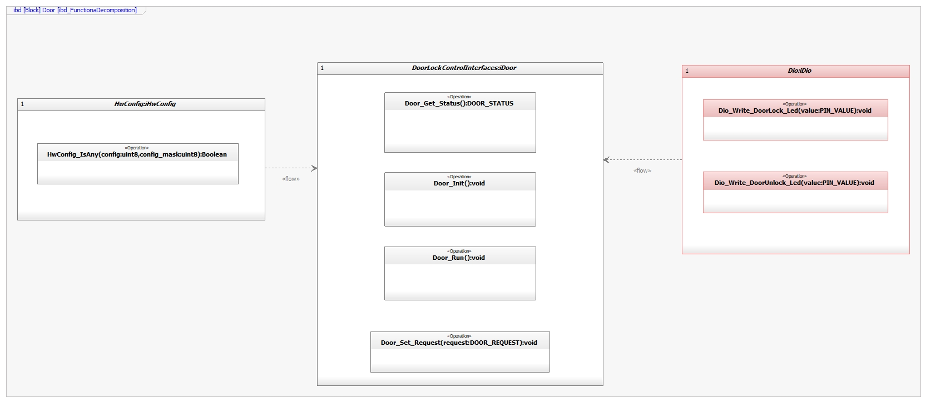

**Function Description and Dynamic Behavior**

## **Function** void Door_Send_Request(DOOR_STATUS):PIN_VALUE

|  |  |
| --- | --- |
| **Description** | This function reads the locking status of the Door from the Dio Component, initializes and runs Door Component and sends Door Status information to DoorApp. |
| **Parameter 1** <input| output| inout> | No parameters will be used in this function |
| **Parameter 2..n** |  |
| **Return Value** | DOOR_STATUS |
| **Precondition** | *Function will periodically check for changes in locking status value* |
| **Post condition** | Depending on the value of DOOR_STAUS, Door shall be considered as Locked, Unlocked, Unknown or Error. |
| **Error Conditions** | If SW_DOOR_LOCKED and SW_DOOR_UNLOCKED are determined as SW_ACTIVE or if SW_DOOR_LOCKED and SW_DOOR_UNLOCKED are determined as SW_INACTIVE then Door Lock shall be considered as ERROR |
| **Requirements** | DCU_SWR_20  DCU_SWR_21  DCU_SWR_22  DCU_SWR_23  DCU_SWR_24 |

**Dynamic Behavior**

